SPI Triathlon Spring 2021
Start:
Parrot Eyes Restaurant-Bar and Water Sports
5801 Padre Blvd, South Padre Island, TX 78597
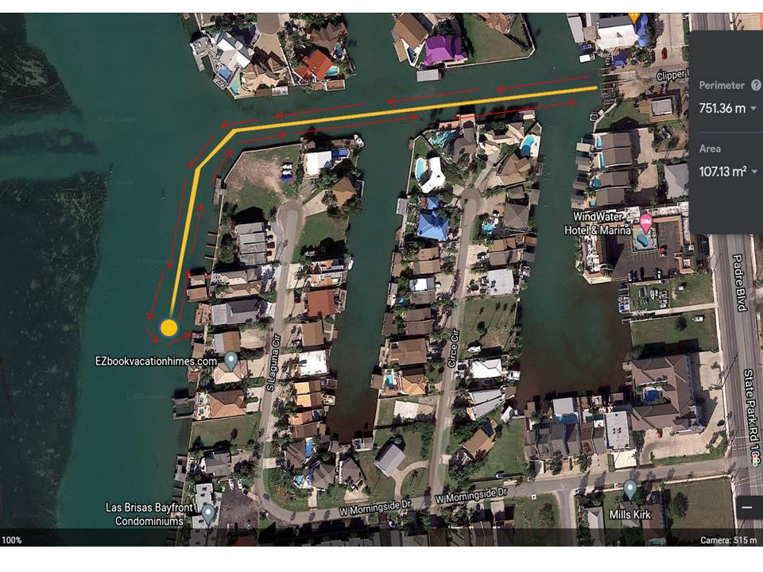

Swim Course: 750 meters
Turnaround: Orange Dot

