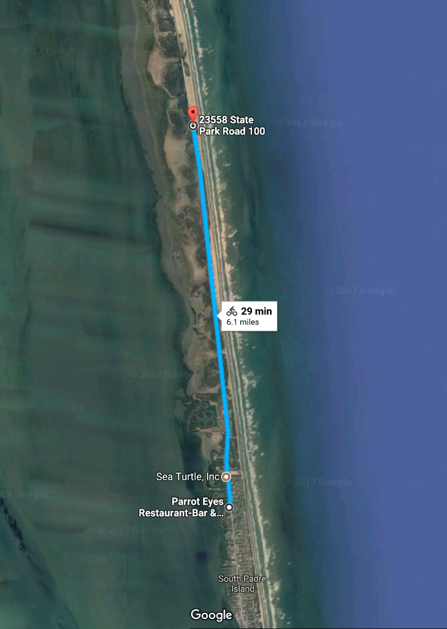

**Beach Access 6**

**BIKE COURSE**

**Start/Finish**

1 loop – 12.4 miles